After Install Jenkins now we need to create users and assign roles to the users

Here I will create 2 users Dev and Tester and assign few permissions to the users

In order to create permission for the users we need to install role base plugins

Create a user:- Manage Jenkins->Manage Users->Create User

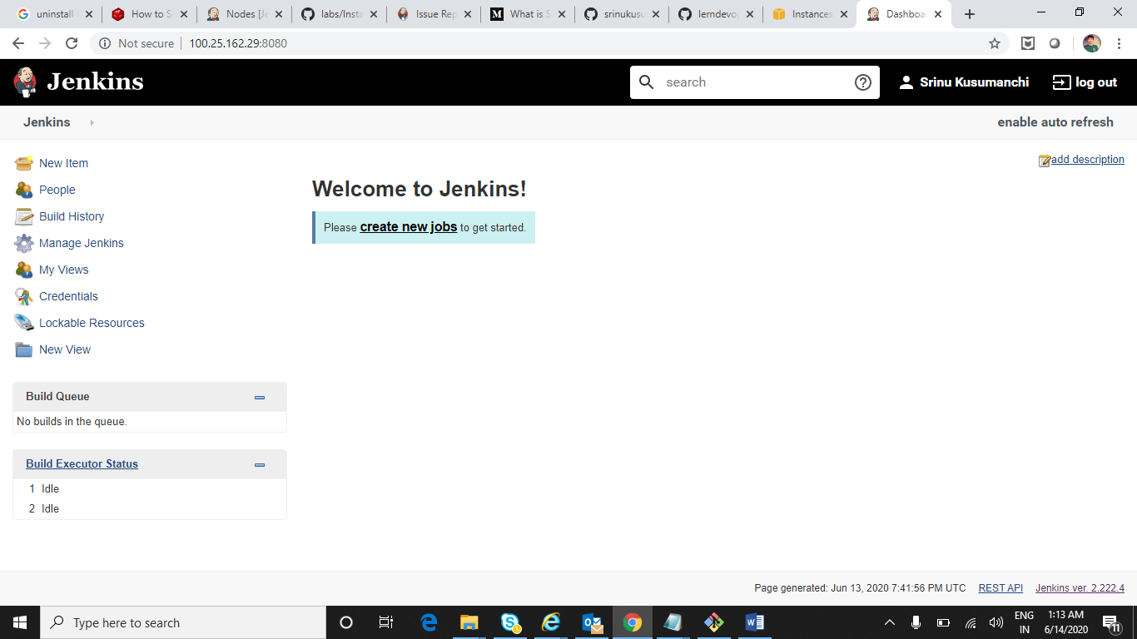

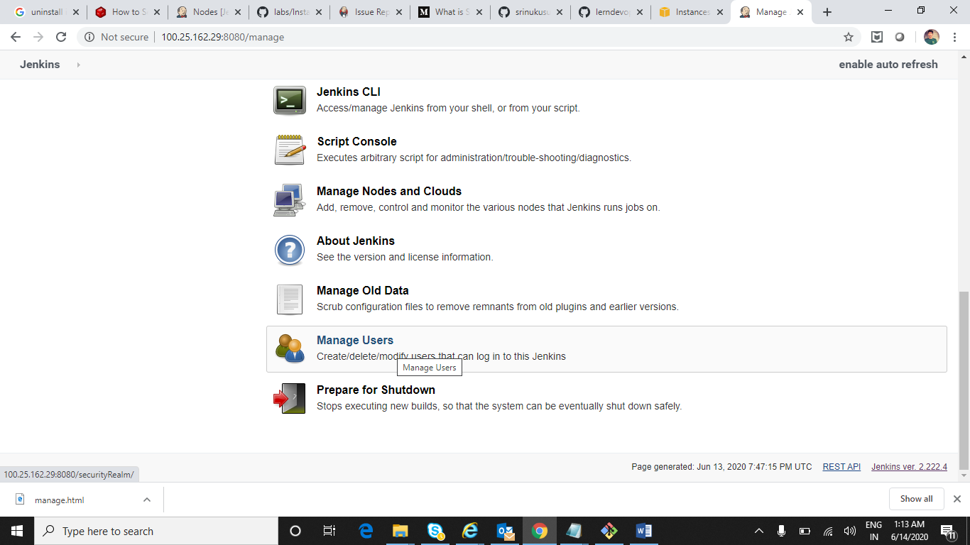

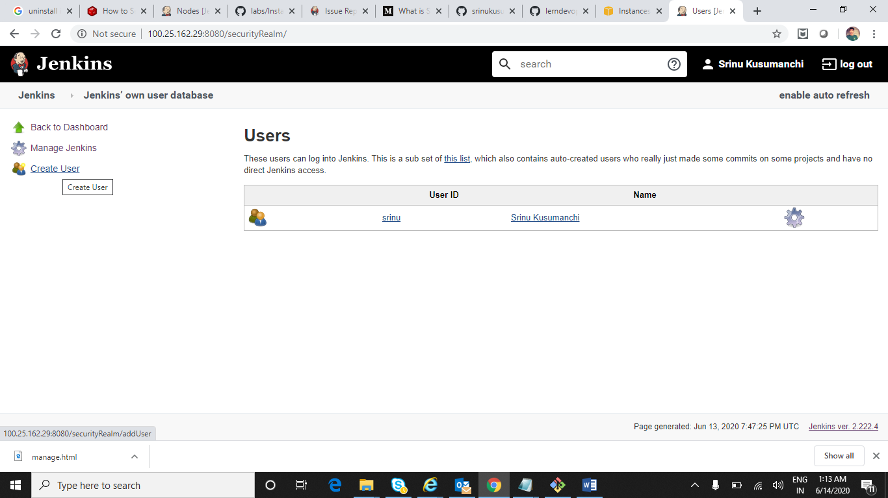

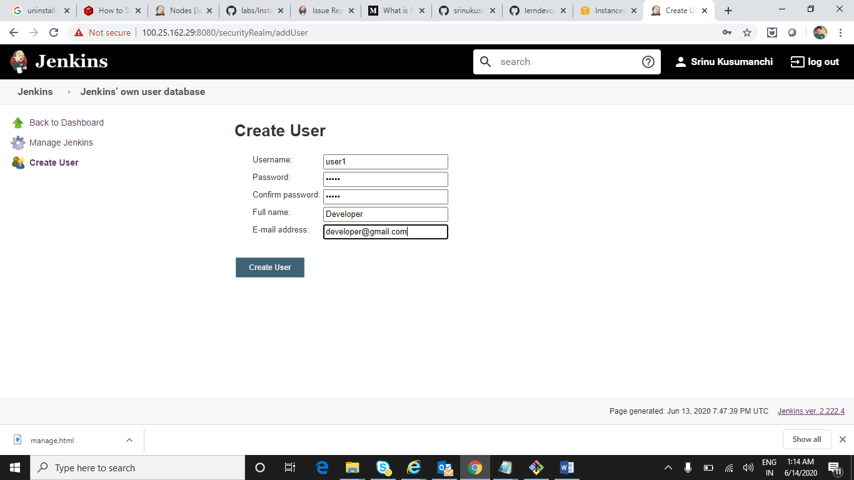

Created 2nd User

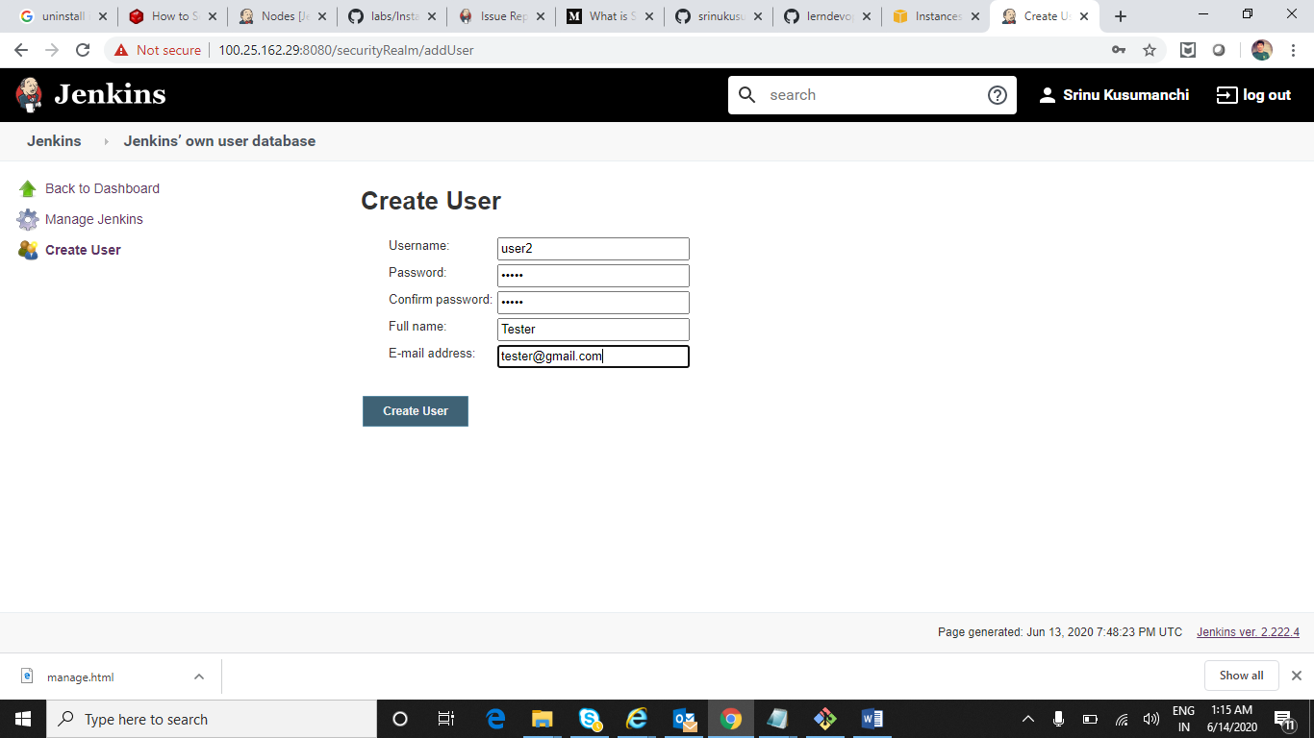

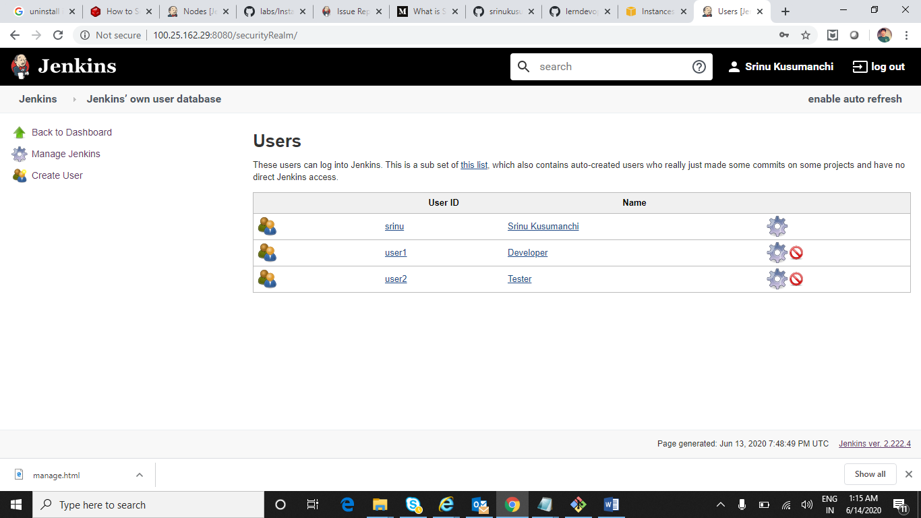

Download Role Based Plugin

Manage Jenkins-> Manage Plugins->Available

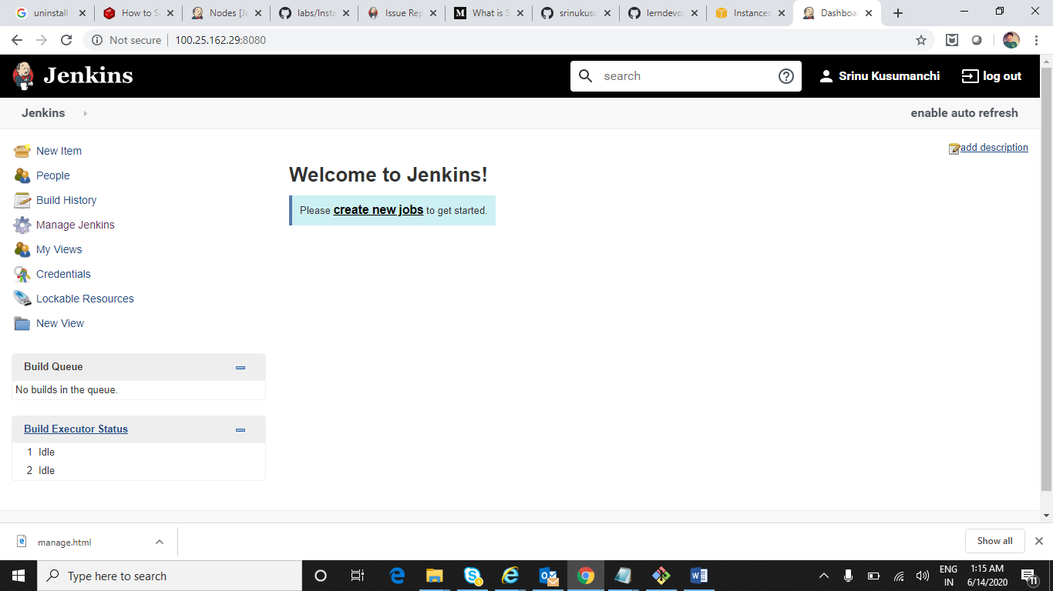

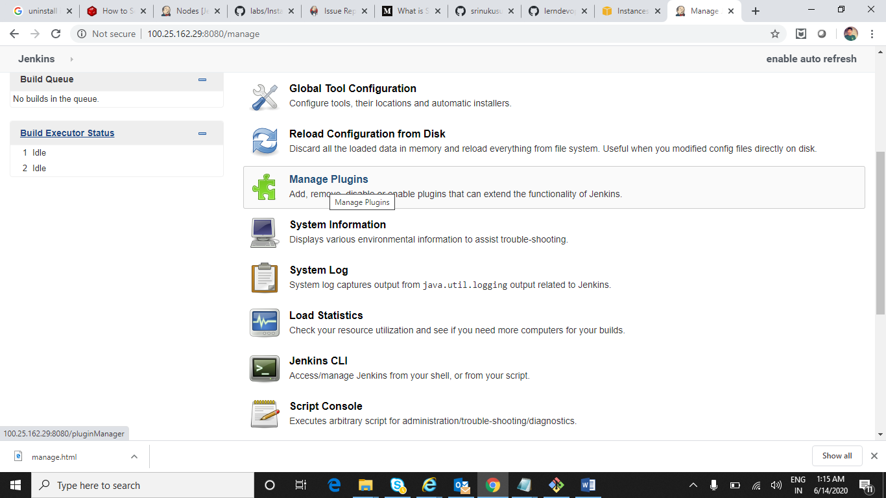

Search for role based plugin and check particular plugin and click on Install without restart

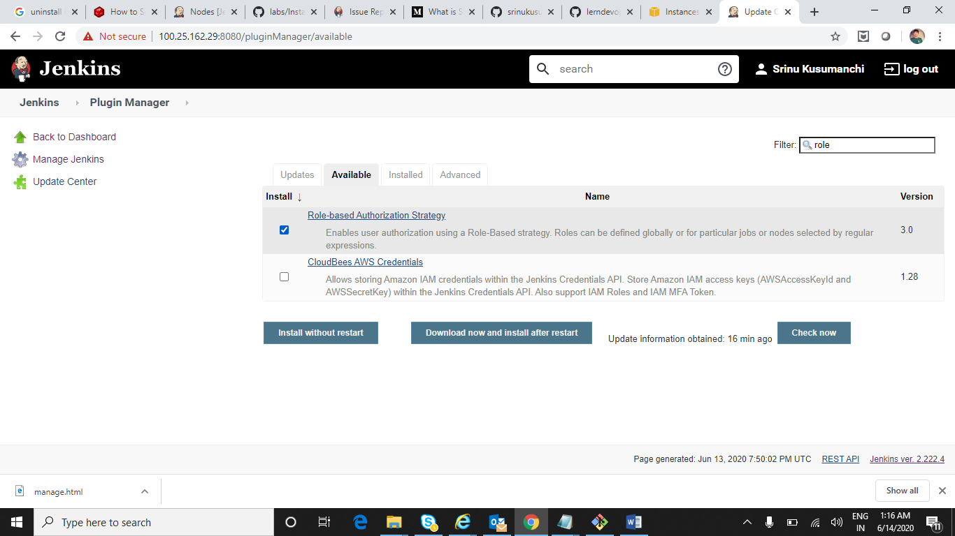

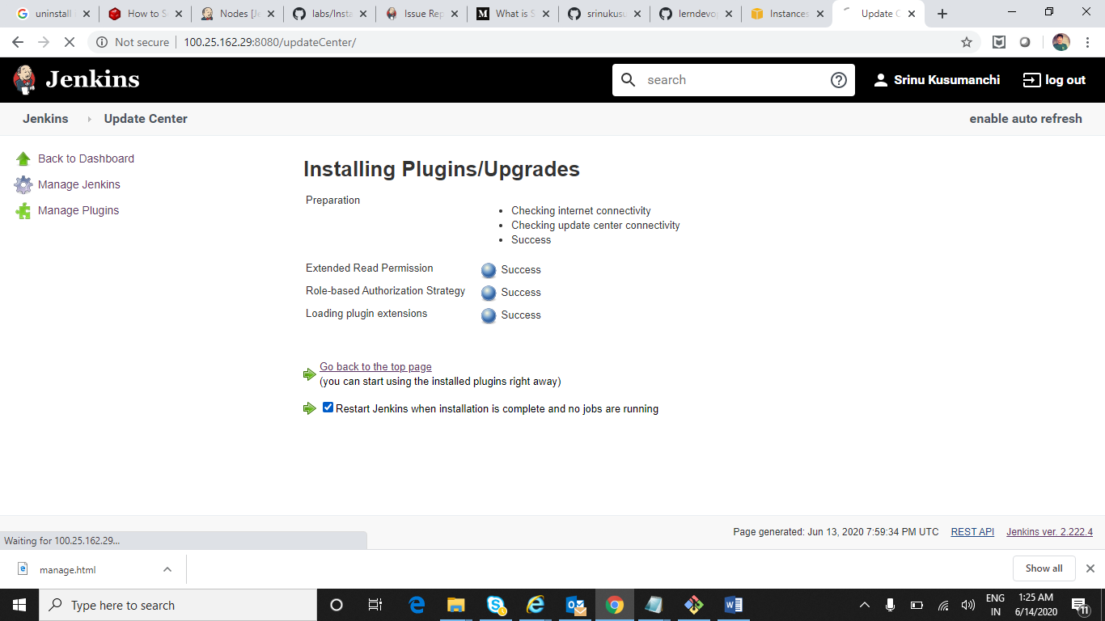

After Installation Role Based Plugin click on Cofigure Global Security

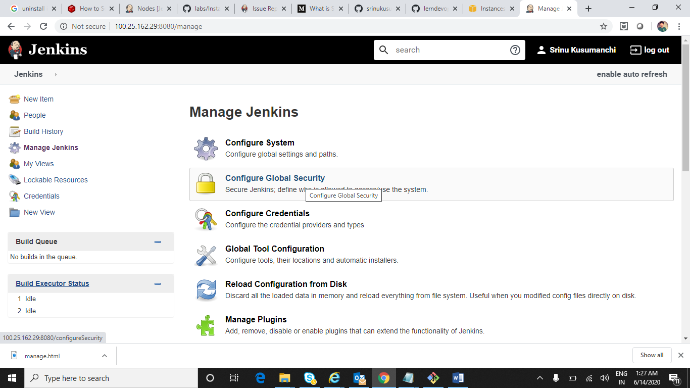

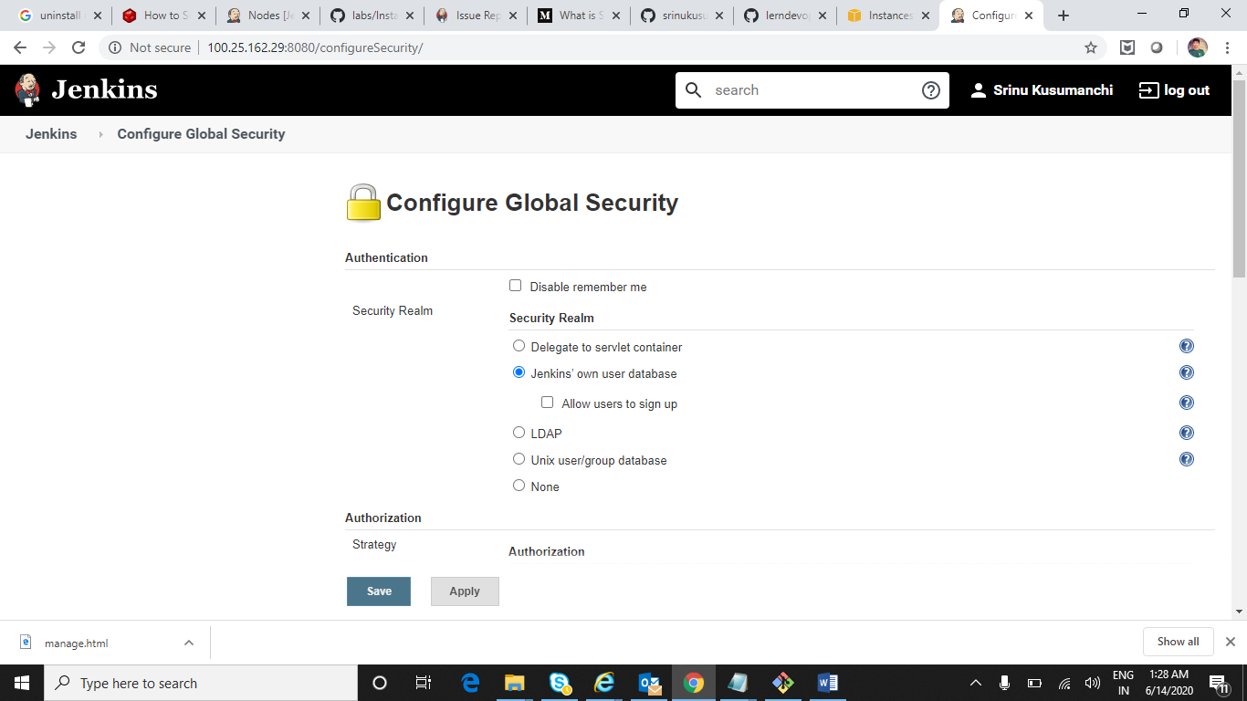

Select Roel-Based Stratergy and click on Apply and save

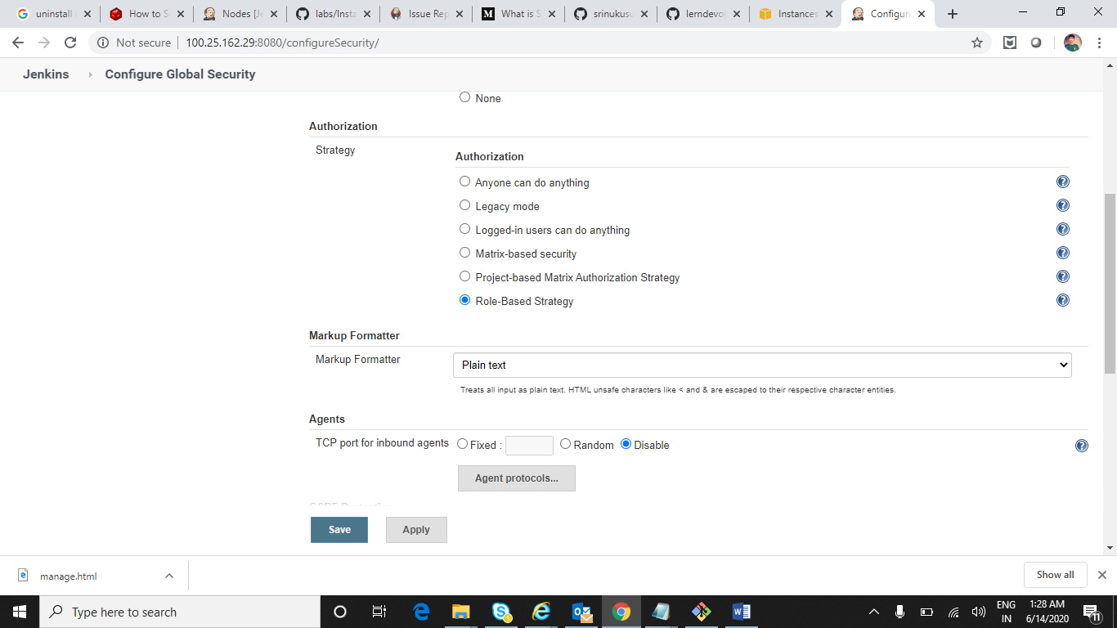

Now assign certain priviliges to user1 and user2

Once after installation of role based plugin we can able to see Manage and Assign roles option in Manage Jenkins

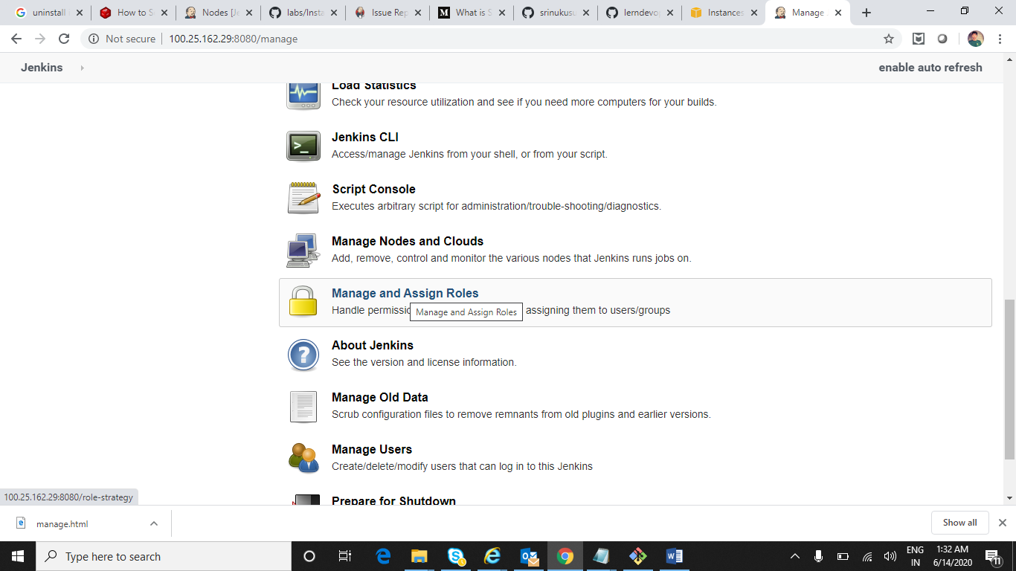

First Manage Roles

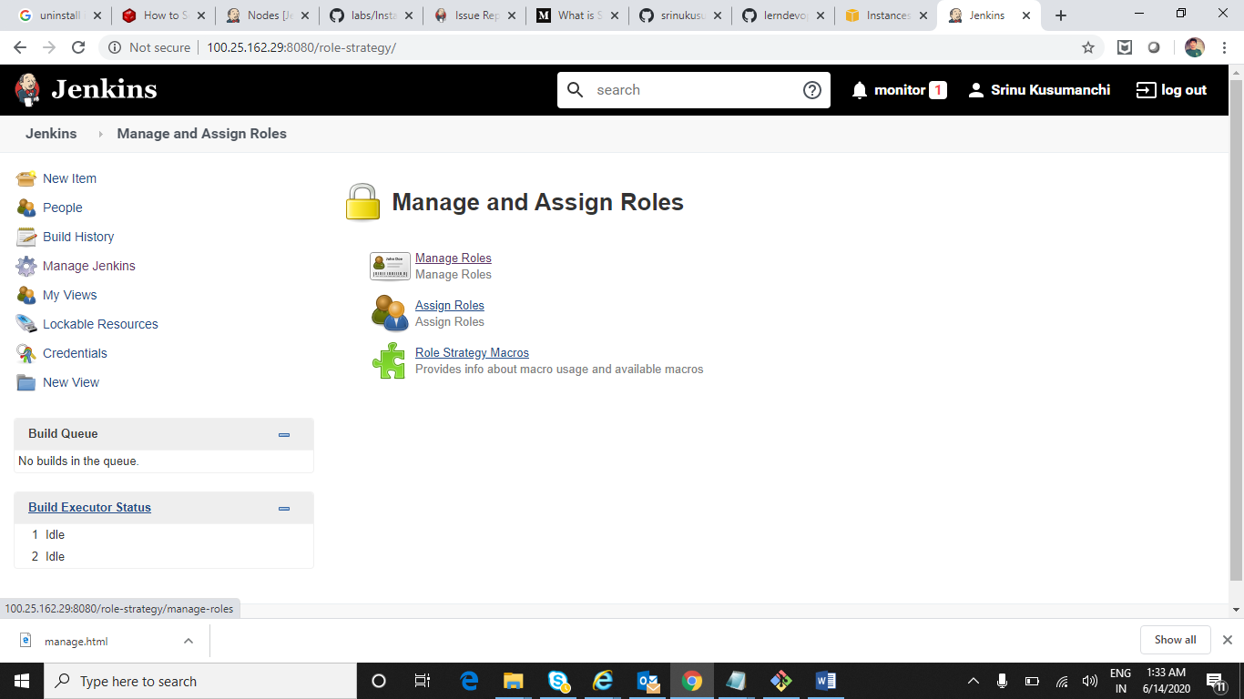

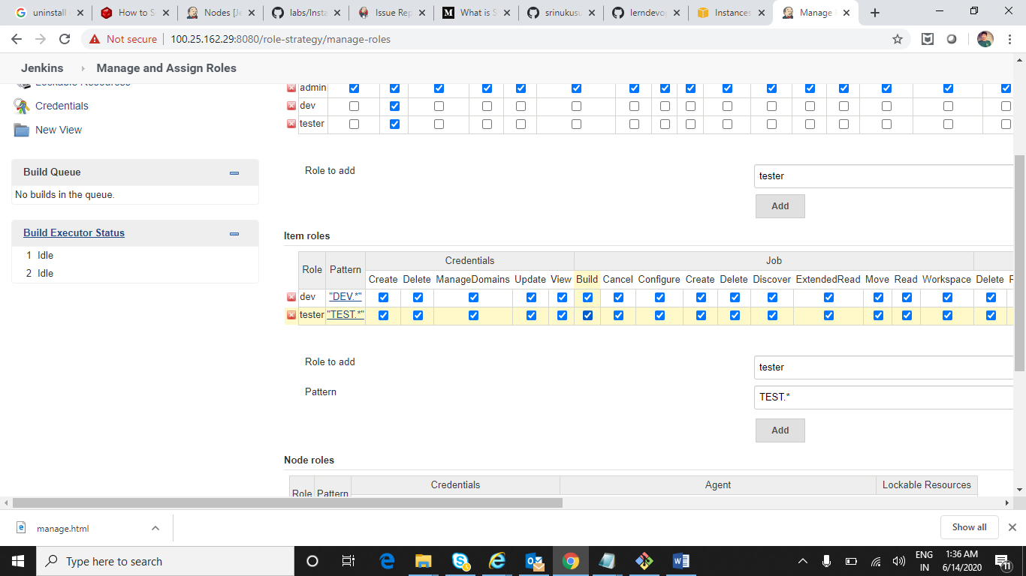

Now Apply and Save

Assign Roles to user1 and user2

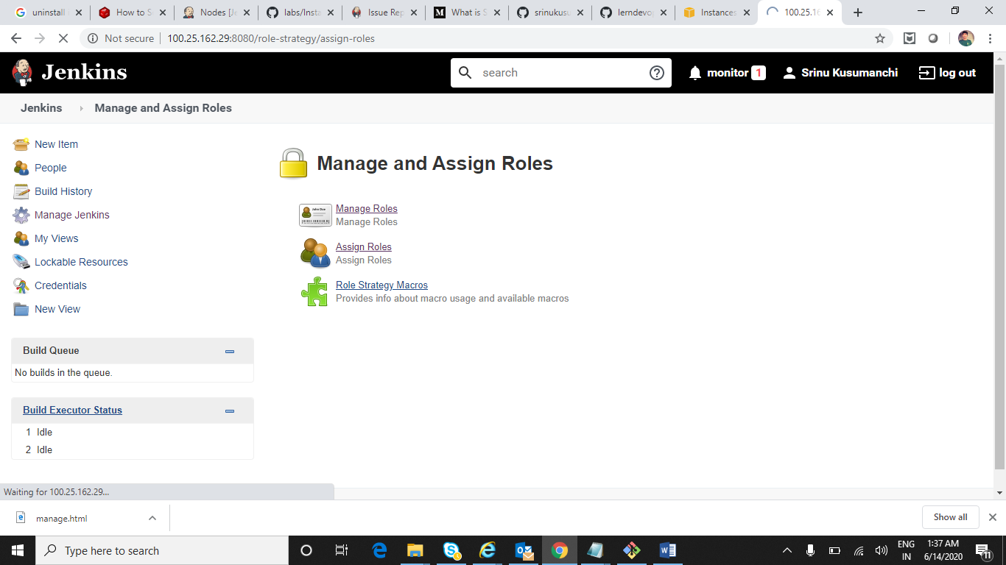

Based on privileges when they login it will be shown and as well as project also shown based on specific pattern

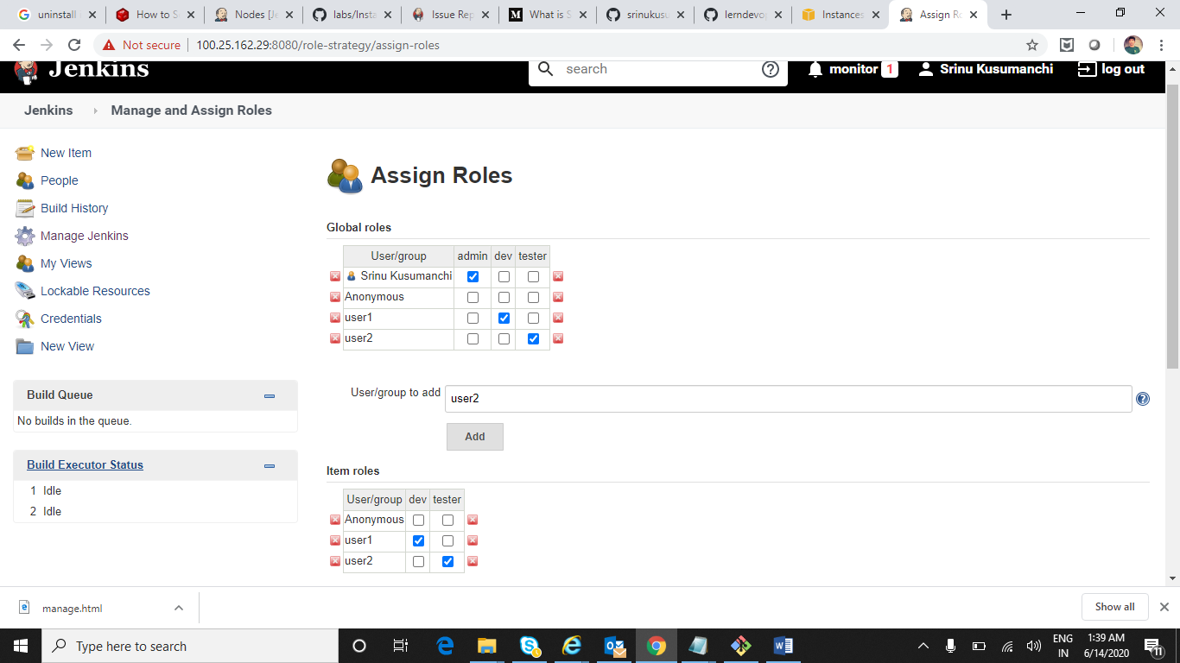

Create DEV_Practice and TEST_Practice (Free Style)Jobs by ADMIN

Click on New Item

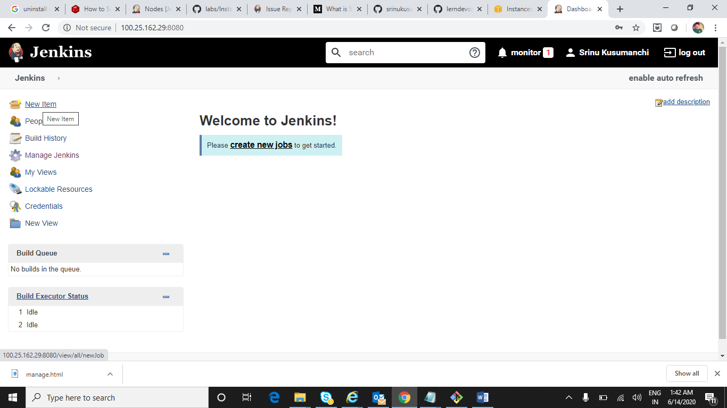

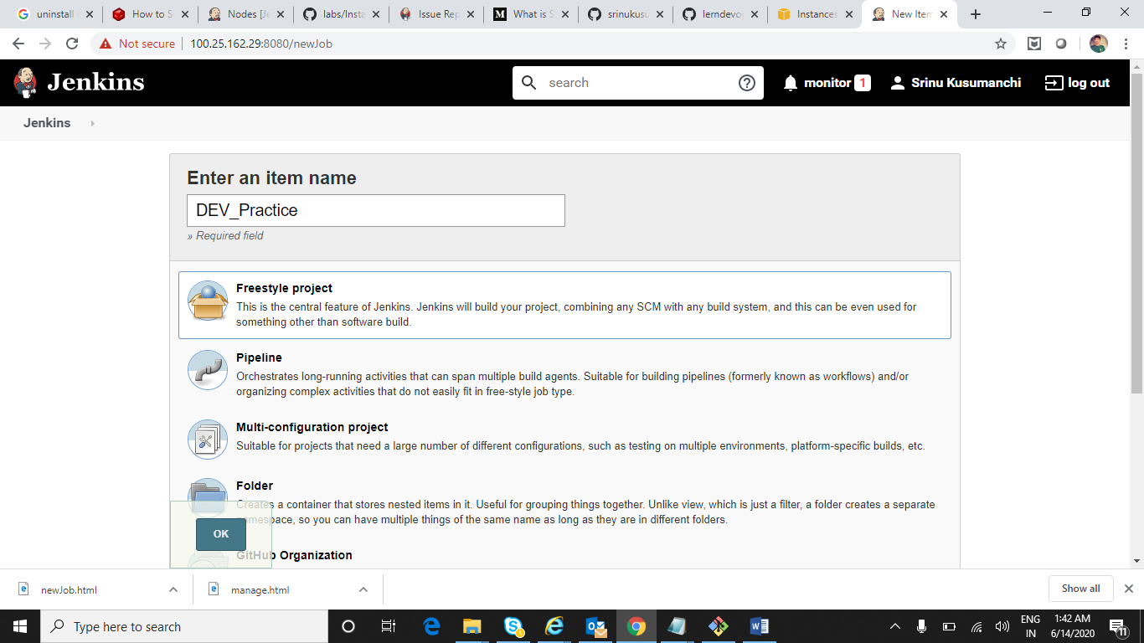

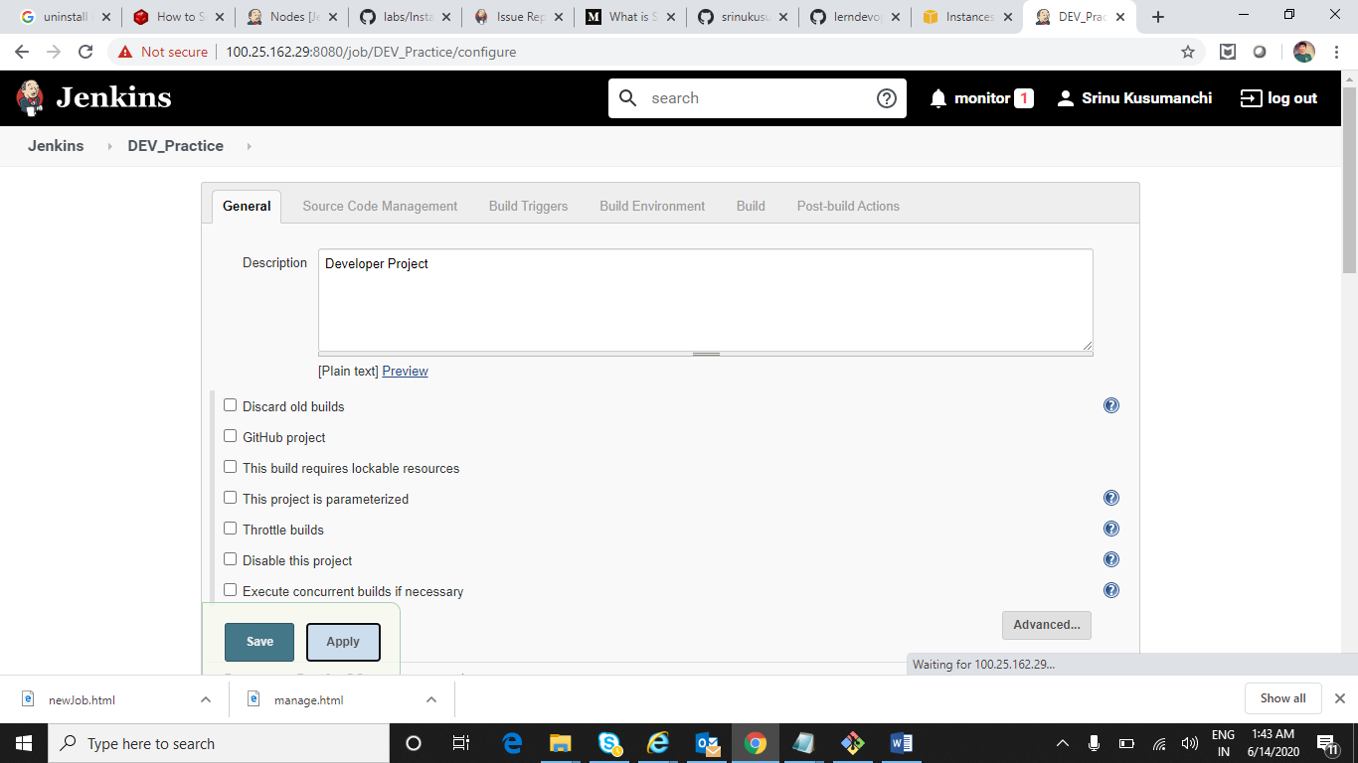

Created 2 Jobs

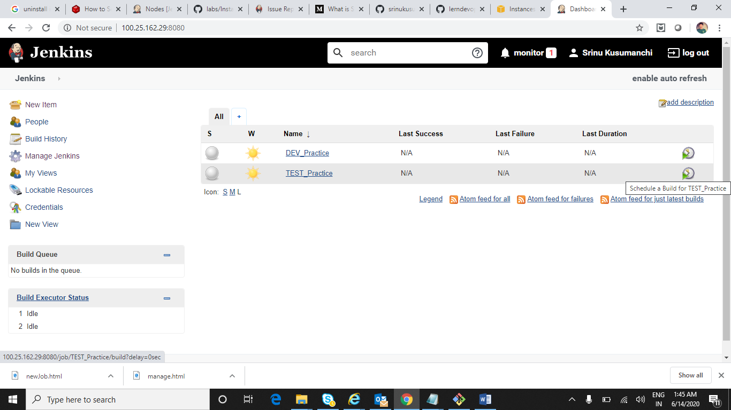

Login to User 1 and User 2 and check they are having only certain priviliges or not and can access to their respective jobs

